THE CHALLENGE OF GEOTOURISM IN GREECE: GEOCULTURAL ROUTES IN ZAGORI REGION (NW GREECE)

Georgia KANELLOPOULOU1

1 PhD student, Department of Cultural Heritage Management and New Technologies, University of Patras, Seferi 2, 30100, Agrinio, Greece

geozagori@gmail.com

## Abstract

*Geotourism focuses on living experience through the contact of geoenvironmental and cultural components that constitute the particular identity of a region. Zagori is a geographical unity which represents the combined work of Nature and Human depicting the evolution of the local society under the influence of the physical constraints of this mountainous area. In the proposed geocultural routes the dialectic relationship between Human and Nature is determined by historical conditions and by the record of the process that transforms space into a landscape. Following these routes we collect herbs following the path of Vikogiatroi (local healers of the 18th century), we walk on cobbled stone paths. At the same time we are travelling back in geological time when the glaciers’ melting water was curving the sediments of Tethys Ocean.*

## Geotourism-a new form of experiential tourism

During the 1980s, the negative effects of mass tourism combined with the proposal of sustainable development strengthened new types of sustainable tourism such as rural tourism, ecotourism, cultural, ski, trekking and mountaineering tourism. It may be said that geotourism encompasses ecotourism and cultural tourism and is considered as a modern form of sustainable tourism, which is developing dynamically the last two decades in many countries. Ecotourism promotes the natural heritage conservation and tourists delight the natural environment, while cultural tourism promotes the cultural heritage conservation and tourists contact with the local cultural components (tangible and intangible).

Geotourism has more than one definition and thus has many aspects. Actually, geotourism is connecting the geological heritage with the natural environment and the cultural monuments1. Furthermore, it focuses on living experience through the contact of geoenvironmental and cultural attributes that constitute the particular identity of a region2. The motivations in developing a geotouristic destination are mainly the experience and the knowledge. Therefore, geotourists are searching places to explore and experience the authenticity of geocultural heritage3. According to Travel Industry Association of America and National Geographic, geotourism is defined as tourism that sustains or enhances the geographical character of a place-its environment, culture, aesthetics, heritage, and the well-being of its residents4. Based on this definition, geotourists also will gain awareness of the environment and will travel in order to know the culture and unique characteristics of a given destination. Recently, geotourism was redefined as: “the provision of interpretative and service facilities for geosites and geomorphosites and their encompassing topography, together with their associated in situ and ex situ artefacts, to ensure their protection and conservation through sustainable management for the purposes of appreciation, enjoyment, education and research by future generations”5.

Geoheritage is the driving force of the geotourism itineraries and cultural heritage is also added to increase the value of the visited regions.Geoheritage comprises those elements of the Earth's geodiversity (rocks, minerals, fossils, landforms, sediments, water and soils) that are considered to have significant scientific, educational, cultural or aesthetic value6. Traditionally, the valorization and the use of geological valuable areas as touristic resources has been linked to areas characterized by the beauty of the landscape, the spectacular rock formations or relevant features (mountains, glacier formations, rivers, canyons, caves, etc.) interesting for people loving geology or, at least, nature.

A geopark is an area enclosing features of special geological significance, rarity or beauty. It is designated with a focus on three main components: the protection and the conservation of Earth’s heritage, the tourism-related infrastructural development and the socio-economically sustainable development of the local community using a sustainable territorial development strategy. Heritage sites within a geopark can be related not only to geology but also to archaeology, ecology, history and culture7. All these sites in a geopark constitute thematic parks and must be linked in a network with routes, trails and sections that should be protected and managed. Thus, the establishment of a geopark not only opens up new opportunities and creates enthusiasm for geoconservation but the park also becomes a new tourist attraction.

In 2000, the European Geopark Network8 was established aiming at protecting the geological heritage and promoting the sustainable development of geopark territories in Europe through geotourism. At present, there are 69 European Geoparks in 23 countries offer the best reception to visitors ready to meet their needs and desires of discovery (Figure 1). On 17 November 2015, the 195 Member States of UNESCO ratified the creation of a new label, the UNESCO Global Geoparks9. This expresses the importance of managing geological sites and landscapes in a holistic manner. At present, there are 120 UNESCO Global Geoparks in 33 countries.

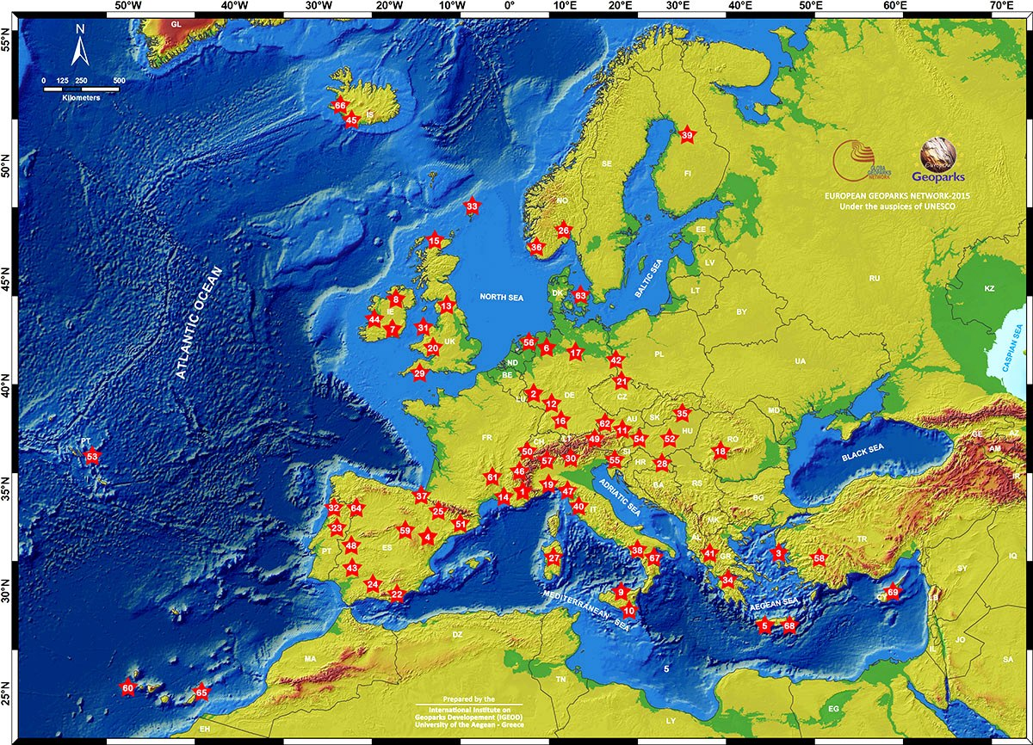

**Figure 1:** Distribution of European Geopark Network members

Geotourists can be people with minimum, or none, knowledge of geology, which come to visit an area (geopark or other) attracted simply by the beauty of the landscape or by having been told or seen it in a touristic guide. It may be said that geotourism could also play a role in promoting local cuisine, products, workshops, festivals, fairs and handicrafts as cultural components and in experiential learning10.

## Geocultural routes-a dynamic touristic product

In recent years, the guidelines of sustainable tourism define the meaning of environmentally friendly activities such as hiking, cycling, participating in traditional production processes, observing flora and fauna etc. The development of themed routes as tourist attractions has gained prominence. Currently, trails and routes have been popular in tourism, representing an important factor in shaping travel patterns11. Changing tourism trends have led to a shift from mass tourism to more individualistic journeys with meaningful experience being their pivotal part12.

Geoparks due to their rich and valuable geocultural heritage have a significant comparative advantage in attracting tourists wanting authentic new experiences. The formation of diverse geocultural routes is considered to be a good way to achieve this, representing a tool for economic and tourism development. The essential concept of route tourism is combining the attractions into regional packages to promote local tourism by encouraging the visitors to travel from one location to another13. It is significant that at European level has been defined more than 25 species of thematic routes involving tourism recreation, outdoor activities, culture, traditional crafts and skills, traditional production processes and products, gastronomy, health, wellness, education, learning, environmental policies and practices, ecology, scientific observation, sports etc14.

Therefore, geocultural routes can be the most important management and interpretative tool for geotourism development by specifying a conceptual-thematic framework relevant to the local geocultural heritage. Geocultural routes are mainly interdisciplinary and experiential paths. The selection of the content is not limited to natural and historical information but incorporates the geoenvironment with the cultural character of the landscape, as the designing goal of this touristic product is the perception of timelessness of space. While designing a matrix of geocultural routes the old path networks are revealed, activating the same time the local community. In these routes tourists through experiential activities turn into travelers, exploring the features of a place, creating experiences and final emotional binding.

## Vikos-Aoos geopark and Zagori region

The Greek geopark network consists of 5 members15: the Petrified Forest of Lesvos (year of establishment-2000), the Psiloritis Natural Park (year of establishment-2001), the Chelmos-Vouraikos National Park (year of establishment-2009), the Vikos-Aoos National Park (year of establishment-2010) and the Sitia Natural Park (year of establishment-2015). Vikos-Aoos geopark is located in North West Greece (Figure 2-left side) and is considered to be an extremely important protected area as it combines in a unique way the natural and the cultural heritage (Figure 2-right side).

Zagori region, supported by its strategic location within the boundaries of Vikos-Aoos geopark, boasts a wealth of geosites, where the steep-rocky mountaintops of Tymphi mountain range alternate with Vikos Canyon and Voidomatis river. Geodiversity, together with an appealing ecological and cultural environment, creates an attractive tourist destination. Throughout history, human beings have found shelter and have constructed a unique set of infrastructures in this environment. Stone bridges skillfully connecting narrow passages and stretching over fast-flowing rivers, cobblestone trails and paths, and stone-built villages were aptly combined and intertwined with the geological environment.

|  |  |
| --- | --- |
|  |  |

**Figure 2:** Zagori region in NW Greece (left side) and the main geocultural features of Vikos-Aoos geopark (right side)

## Geocultural routes in Zagori region

Till now eight geocultural routes have been developed to link these cultural and ecological sites with the geological heritage. Along the routes, the geodiversity is explained, including its relationship with the surrounding biodiversity, and the historical and cultural aspects of the region. The methodology for planning those routes was based on the following features, that compose the local identity:

* the geoenvironmental resources,
* the information about prehistory and history,
* the discrete architecture,
* the natural and cultural heritage components,
* the inferences of the past relationship between Human and Nature as a balanced and sustainable status,
* the aesthetic values.

The geocultural routes are accompanied by a structured narrative based on the Human-Nature relationship. Each narrative is the result from the extensive field research. The local culture is approached by means of modern theoretical evolution in social science through a holistic and interdisciplinary perspective. The dialectic Human-Nature relationship is determined by historical conditions by recording the processes transforming the space into landscape. Moreover, the use of the interpreting method contributes to a deeper understanding of the relevance of the whole and its elements (Figure 3).



**Figure 3:** Geotourism as an experience

Following a route we experience the manufacture of sheep wool, of milk products, we collect herbs following the path of Vikogiatroi (local healers of the 18th century), we walk on cobbled stone paths when the same time we are travelling back in geological time when the glaciers’ melting water was curving the sediments of Tethys Ocean. In this way, the geocultural routes are not limited only in a hiking experience but they are offered as a complete experiential travel package, which consists of interpreting services and contact of local heritage. Thus, we develop synergies with agrotourism guesthouses, local producers, local associations, ecomuseums, management agencies and finally the geocultural routes acquire thematic like: “The drystone route”, “The herbs route“ and “The Cheese route” (Figures 4, 5, 6).

|  |  |
| --- | --- |
|  |  |

**Figure 4:** Geocultural route: «The drystone route»

|  |  |
| --- | --- |
|  |  |

**Figure 5:** Geocultural route: «The herbs route»

|  |  |
| --- | --- |
|  |  |

**Figure 6:** Geocultural route: «The Cheese route»

## Conclusions

Geotourism can play a leading role in the field of tourism and especially of experiential tourism. As geotourism is a sustainable type of nature-based tourism that focuses on nature-related new experiences and knowledge, it has the less negative impact; it is not part of mainstream tourism and its development is in the interest of the local community. Promoting heritage sites through geoparks is carried out through education and conservation efforts aimed at increasing the knowledge and value of geological heritage, cultural heritage and biological heritage. Local community’s participation in the decision-making process of the development and management of geoparks and geotourism will improve their livelihood and strengthen their appreciation of the value of their geolcultural heritage; so they can give their awareness to visitors.

## References

1. D. Newsome, R. Dowling and Y. Leung, “The Νature and Μanagement of Geotourism: A Case Study of two Established Iconic Geotourism Destinations”, *Tourism Management Perspectives*, **2-3**, 19-27 (2012).
2. D. Newsome and R. Dowling, *Geotourism: The Tourism of Geology and Landscape*. Goodfellow Publishers, Oxford, 2010.
3. N. T. Farsani, C. Coelho and C. Costa, “Geotourism and geoparks as novel strategies for socio-economic development in rural areas”, *International Journal of Tourism Research*, **13** (1) 68-91 (2011).
4. A.M. Stokes, S.D. Cook and D. Drew, “Geotourism: the new trend in travel”, *Travel Industry Association of America*, Sponsored by National Geographic Traveler, 2002.
5. *T*.A. Hose, “3gs for modern geotourism”, *Geoheritage*, **4** (1–2), 7–14 (2012).
6. International Union for Conservation of Nature, “Geoheritage definition”, https://www.iucn.org/about/work/programmes/gpap_home/gpap_biodiversity/gpap_wcpabiodiv/gpap_geoheritage/
7. UNESCO, *Global Geoparks Network*, Published by Division of Ecological and Earth Sciences, Παρίσι, 2006.
8. http://www.europeangeoparks.org/
9. http://www.unesco.org/new/en/natural-sciences/environment/earth-sciences/global-geoparks/
10. T.A. Hose, “The English Origins of Geotourism (as a Vehicle for Geoconservation) and their Relevance to Current Studies”, *Acta Geographica Slovenica*, **51** (3) 343–359 (2011).
11. D. Timothy and S. Boyd, “Tourism and trails: Cultural, ecological and management issues”, Channel View Publications, Bristol, 2014.
12. R. Hummelbrunner and E. Miglbauer, “Tourism promotion and potential in peripheral areas: The Austrian case’, *Journal of Sustainable Tourism*, **2**, 41–50 (1994).
13. D. Meyer, “*Tourism routes and gateways: Key issues for the development of tourism routes and gateways and their potential for Pro-Poor Tourism*”, Overseas Development Institute, London, (2004).
14. B. Lane, Sustainable Rural Tourism Strategies: A Tool for Development and Conservation, *Journal of Sustainable Tourism*, **2** (1-2), 1994.
15. http://www.hellenicgeoparks.gr/